PRACTICAL - 8
AIM: Build PERT networks, estimate activity times, and calculate project durations and completion probabilities.
Task:
- Consider a software development project with the following activities:
A: Define Requirements,B: Design Database,C: Develop Frontend,D: Implement Backend,E: Perform Testing,F: Deployment
The dependencies are as follows:
A depends on nothing,B depends on A,C depends on A,D depends on B and C,E depends on D,F depends on E,
Construct a PERT network diagram for this project.
Consider the following PERT estimates for a software development project:
Activity A: Optimistic Time = 2 weeks, Most Likely Time = 4 weeks, Pessimistic Time = 6 days
Activity B: Optimistic Time = 3 weeks, Most Likely Time = 5 weeks, Pessimistic Time = 7 days
Activity C: Optimistic Time = 3 weeks, Most Likely Time = 6 weeks, Pessimistic Time = 9 days
Activity D: Optimistic Time = 4 weeks, Most Likely Time = 7 weeks, Pessimistic Time = 10 days
Activity E: Optimistic Time = 2 weeks, Most Likely Time = 4 weeks, Pessimistic Time = 6 days
Activity F: Optimistic Time = 1 week, Most Likely Time = 2 weeks, Pessimistic Time = 3 days
Determine estimate activity times, and calculate project durations probabilities of completing the project within 14 weeks.
Solution:
Team Details:
Sr. No. | Enrolment no | Name
Team Leader | Yash Patel | 202203103510228
Team Member 1 | Gati Shah | 202203103510261
Team Member 2 | Angat Shah | 202203103510097
Team Member 3 | Fenil Shilodre | 202203103510041
Team Member 4 | Sarth Chaudhari | 202303103510106

Project Title : Airbnb System

PERT Time Estimation
Activity | Description | Optimistic (O) | Most Likely (M) | Pessimistic (P)
A | Requirement Analysis | 4 | 5 | 6
B | UI/UX Design | 6 | 8 | 10
C | Backend Development | 8 | 10 | 12
D | Frontend Development | 10 | 12 | 14
E | Payment Gateway Integration | 5 | 6 | 7
F | Testing | 6 | 8 | 10
G | Deployment | 3 | 4 | 5

Calculation For Expected Time (TE) For Each Activity
- PERT Formula for Expected Time :
$TE =\frac{ O + 4M + P}{6}$

Activity | TE Calculation | Expected Time (TE)
A | $\frac{ 4 + 4(5) + 6}{6} = \frac{ 30}{6}$ | 5 Weeks
B | $\frac{ 6 + 4(8) + 10}{6} = \frac{ 48}{6}$ | 8 Weeks
C | $\frac{ 8 + 4(10) + 12}{6} = \frac{ 60}{6}$ | 10 Weeks
D | $\frac{ 10 + 4(12) + 14}{6} = \frac{ 72}{6}$ | 12 Weeks
E | $\frac{ 5 + 4(6) + 7}{6} = \frac{ 36}{6}$ | 6 Weeks
F | $\frac{ 6 + 4(8) + 10}{6} = \frac{ 48}{6}$ | 8 Weeks
G | $\frac{ 3 + 4(4) + 5}{6} = \frac{ 24}{6}$ | 4 Weeks
- Critical Path Analysis (PERT)
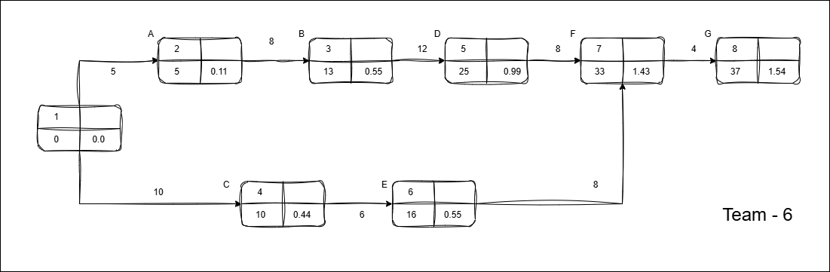PERT Network
- From CPM, the critical path : A → B → D → F → G
- Total duration = 5 + 8 + 12 + 8 + 4 = 37 weeks
(No change from CPM since, TE = original durations.)
- Probability of Completing Project in 35 Weeks
- Step 1: Variance (σ²) for Critical Path Activities Calculation
The Formula for Variance :
$σ^{2}={{\left(\frac{P - O}{6}\right)}^{2}}^{}$

Activity | P - O | σ² | σ
A | 6 - 4 = 2 | ${\left(\frac{2}{6}\right)}^{2}$ ≈ 0.111 | 0.33
B | 10 - 6 = 4 | ${\left(\frac{4}{6}\right)}^{2}$ ≈ 0.444 | 0.67
D | 14 - 10 = 4 | ${\left(\frac{4}{6}\right)}^{2}$ ≈ 0.444 | 0.67
F | 10 - 6 = 4 | ${\left(\frac{4}{6}\right)}^{2}$ ≈ 0.444 | 0.67
G | 5 - 3 = 2 | ${\left(\frac{2}{6}\right)}^{2}$ ≈ 0.111 | 0.33
Total Variance (Σσ²) = 0.111 + 0.444 + 0.444 + 0.444 + 0.111 = 1.554
- Step 2: Calculation for Standard Deviation (σ)
σ = $\sqrt{1.554}$ ≈ 1.25 Weeks
- Step 3: Computing Z-Score for 35 Weeks
$z = \frac{T - TE}{σ}$ = $\frac{35-37}{1.25}$ = - 1.6
- Step 4: Find Probability from Z-Table
From the standard normal distribution table,
Z | 0.00
-1.6 | .05480
A z-score of -1.6 corresponds to a ~ 5.5% probability.
This makes sense because 35 weeks is 2 weeks shorter than the expected 37-week duration and the variance is relatively low.
- Probability of Completing Project in 39 Weeks
- Step 1: Variance (σ²) for Critical Path Activities Calculation
The Formula for Variance :
$σ^{2}={{\left(\frac{P - O}{6}\right)}^{2}}^{}$
Activity | P - O | σ² | σ
A | 6 - 4 = 2 | ${\left(\frac{2}{6}\right)}^{2}$ ≈ 0.111 | 0.33
B | 10 - 6 = 4 | ${\left(\frac{4}{6}\right)}^{2}$ ≈ 0.444 | 0.67
D | 14 - 10 = 4 | ${\left(\frac{4}{6}\right)}^{2}$ ≈ 0.444 | 0.67
F | 10 - 6 = 4 | ${\left(\frac{4}{6}\right)}^{2}$ ≈ 0.444 | 0.67
G | 5 - 3 = 2 | ${\left(\frac{2}{6}\right)}^{2}$ ≈ 0.111 | 0.33
Total Variance (Σσ²) = 0.111 + 0.444 + 0.444 + 0.444 + 0.111 = 1.554
- Step 2: Calculation for Standard Deviation (σ)
σ = $\sqrt{1.554}$ ≈ 1.25 Weeks
- Step 3: Computing Z-Score for 35 Weeks
$z = \frac{T - TE}{σ}$ = $\frac{39-37}{1.25}$ = 1.6
- Step 4: Find Probability from Z-Table
From the standard normal distribution table,
Z | 0.00
1.6 | .94520
A z-score of 1.6 corresponds to a ~ 94.5% probability.
This makes sense because 39 weeks is 2 weeks longer than the expected 37-week duration and the variance is relatively high.
Project Title : Farfetch E-commerce System

PERT Time Estimation
Activity | Description | Optimistic (O) | Most Likely (M) | Pessimistic (P)
A | Requirement Analysis | 5 | 6 | 7
B | Product Catalog Design | 6 | 7 | 8
C | Recommendation Engine Dev | 12 | 14 | 16
D | Payment Gateway Integration | 8 | 10 | 12
E | UI/UX Design | 7 | 8 | 9
F | Frontend & Backend Development | 16 | 18 | 20
G | Testing | 10 | 12 | 14
H | Deployment | 4 | 5 | 6

Calculation For Expected Time (TE) For Each Activity
- PERT Formula for Expected Time :
$TE =\frac{ O + 4M + P}{6}$
Activity | TE Calculation | Expected Time (TE)
A | $\frac{ 5 + 4(6) + 7}{6} = \frac{ 36}{6}$ | 6 Weeks
B | $\frac{ 6 + 4(7) + 8}{6} = \frac{ 42}{6}$ | 7 Weeks
C | $\frac{ 12 + 4(14) + 16}{6} = \frac{ 84}{6}$ | 14 Weeks
D | $\frac{ 8 + 4(10) + 12}{6} = \frac{ 60}{6}$ | 10 Weeks
E | $\frac{ 7 + 4(8) + 9}{6} = \frac{ 48}{6}$ | 8 Weeks
F | $\frac{ 16 + 4(18) + 20}{6} = \frac{ 108}{6}$ | 18 Weeks
G | $\frac{ 10 + 4(12) + 14}{6} = \frac{ 72}{6}$ | 12 Weeks
H | $\frac{ 4 + 4(5) + 6}{6} = \frac{ 30}{6}$ | 5 Weeks
- Critical Path Analysis (PERT)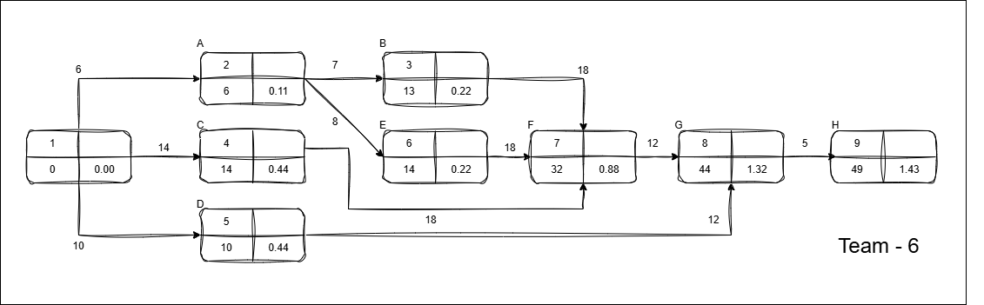
PERT Network
- From CPM, the critical path is: C→ F → G → H
- Total duration = 6 + 14 + 8 + 18 + 12 + 5 = 49 weeks.
(Non-critical activities like B and D have slack and won’t delay the project.)
- Probability of Completing Project in 48 Weeks
- Step 1: Variance (σ²) for Critical Path Activities Calculation
The Formula for Variance :
$σ^{2}={{\left(\frac{P - O}{6}\right)}^{2}}^{}$
Activity | P - O | σ² | σ
C | 16 - 12 = 4 | ${\left(\frac{4}{6}\right)}^{2}$ ≈ 0.444 | 0.67
F | 20 - 16 = 4 | ${\left(\frac{4}{6}\right)}^{2}$ ≈ 0.444 | 0.67
G | 14 - 10 = 4 | ${\left(\frac{4}{6}\right)}^{2}$ ≈ 0.444 | 0.67
H | 6 - 4 = 2 | ${\left(\frac{2}{6}\right)}^{2}$ ≈ 0.111 | 0.33
Total Variance (Σσ²) = 0.444 + 0.444 + 0.444 + 0.111 = 1.443
- Step 2: Calculation for Standard Deviation (σ)
σ = $\sqrt{1.443}$ ≈ 1.20 Weeks
- Step 3: Computing Z-Score for 35 Weeks
$z = \frac{T - TE}{σ}$ = $\frac{48-49}{1.20}$ = - 0.83
- Step 4: Find Probability from Z-Table
From the standard normal distribution table,
Z | 0.03
- 0.8 | .20327
A z-score of - 0.83 corresponds to a ~ 20.3 % probability.
This makes sense because 48 weeks is 1 week shorter than the expected 49-week duration and the variance is relatively low.
- Probability of Completing Project in 50 Weeks
- Step 1: Variance (σ²) for Critical Path Activities Calculation
The Formula for Variance :
$σ^{2}={{\left(\frac{P - O}{6}\right)}^{2}}^{}$
Activity | P - O | σ² | σ
C | 16 - 12 = 4 | ${\left(\frac{4}{6}\right)}^{2}$ ≈ 0.444 | 0.67
F | 20 - 16 = 4 | ${\left(\frac{4}{6}\right)}^{2}$ ≈ 0.444 | 0.67
G | 14 - 10 = 4 | ${\left(\frac{4}{6}\right)}^{2}$ ≈ 0.444 | 0.67
H | 6 - 4 = 2 | ${\left(\frac{2}{6}\right)}^{2}$ ≈ 0.111 | 0.33
Total Variance (Σσ²) = 0.444 + 0.444 + 0.444 + 0.111 = 1.443
- Step 2: Calculation for Standard Deviation (σ)
σ = $\sqrt{1.443}$ ≈ 1.20 Weeks
- Step 3: Computing Z-Score for 35 Weeks
$z = \frac{T - TE}{σ}$ = $\frac{50-49}{1.20}$ = 0.83
- Step 4: Find Probability from Z-Table
From the standard normal distribution table,
Z | 0.03
0.8 | 0.79673
A z-score of 0.83 corresponds to a ~ 79.7% probability.
This makes sense because 50 weeks is 1 week longer than the expected 49-week duration and the variance is relatively high.

